Schuyler County Industrial Development Agency
910 South Decatur Street, Watkins Glen, NY 14891
Meeting Minutes
January 12,2022

Call Meeting to Order: The meeting of the Schuyler County Industrial Development Agency (SCIDA) was called to order at 5:00pm by Carl Taber.

Roll Call: | Hon. Carl Blowers  Carl Taber  John Terry  Margaret Lawrence  Mark Taylor  Kristin Van Horn  Laury Ward  Chad Hendrickson | Schuyler County Legislature  Chair  Vice Chairman  Treasurer  Member  County Planning  Secretary  Member
Excused: | Kevin Murphy | Retired
Guests: | Fonda Chronis | Schuyler County
SCOPED Staff: | Judy McKinney Cherry  Yvonne Zhao | CFO/CEO  Sr. Econ & Community Dev. Specialist

Public Comment
There was no public comment.

Minutes
A motion was made by Carl Taber to approve the minutes of the December 2021 meeting, second by Mark Taylor. Motion carried, unanimously.

Financial Statements
Margaret Lawrence reviewed the December 2021 financials.
A motion was made by Mark Taylor to approve the December 202 financial statements, second by Laury Ward. Motion carried, unanimously.

New Business
Election of officers was completed. Carl Taber is Chairman, John Terry is Vice Chairman, Carl Blowers is Secretary and Margaret Lawrence is Treasurer. Annual sexual harassment training is required annually and being offered to the board. Judy McKinney Cherry will follow up with an email to the board confirming participation.

ABO/PAAA Updates
The authorization for remote meetings is scheduled to expire on the 15th of this month, there is an executive order Governor Hochul put in place for the General Assembly that extends it and they are in the action to extend it.

Committee Reports
Finance Committee – There was no meeting held.

Governance Committee – There was no meeting held.

Audit Committee – There was no meeting held. Audit Committee will be meeting on the second week of February to do the audit.

Ongoing Business
Broadband - No updates

Camp Monterey – New York State has finished the survey and appraisal. In the middle of changing the contact in the ESD real estate office. The State needs to finish writing the legal description of the property so the town of Orange can accept it as a table parcel and put it into the real estate system.

Business Park - Judy McKinney Cherry summarized the current situation about the lease. The FLX Enterprises does have a deadline of the construction portion of the debt taken care or at lease handled by the end of March.

This item was not on the agenda, but the board discussed the RFP summary on Seneca Harbor Marina Restaurant for a one-year lease. The RFP is available on the SCOPED website.

Adjournment
A motion was made by John Terry to adjourn the meeting at 6:30 PM, second by Mark Taylor. Motion carried, unanimously.

Respectfully submitted,
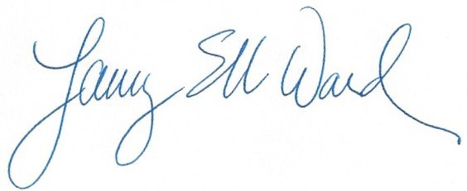

Laury Ward Secretary

